SET 1:

ITEM 1 (savings):

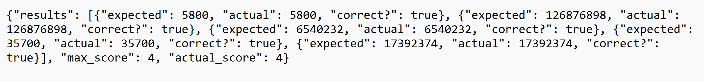

ITEM 2 (material_waste):

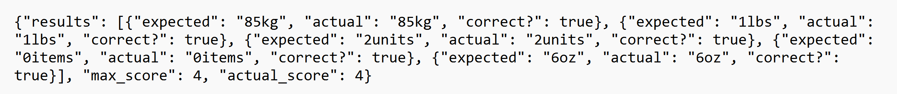

ITEM 3 (interest):

